KV KENT VENTURES GROUP
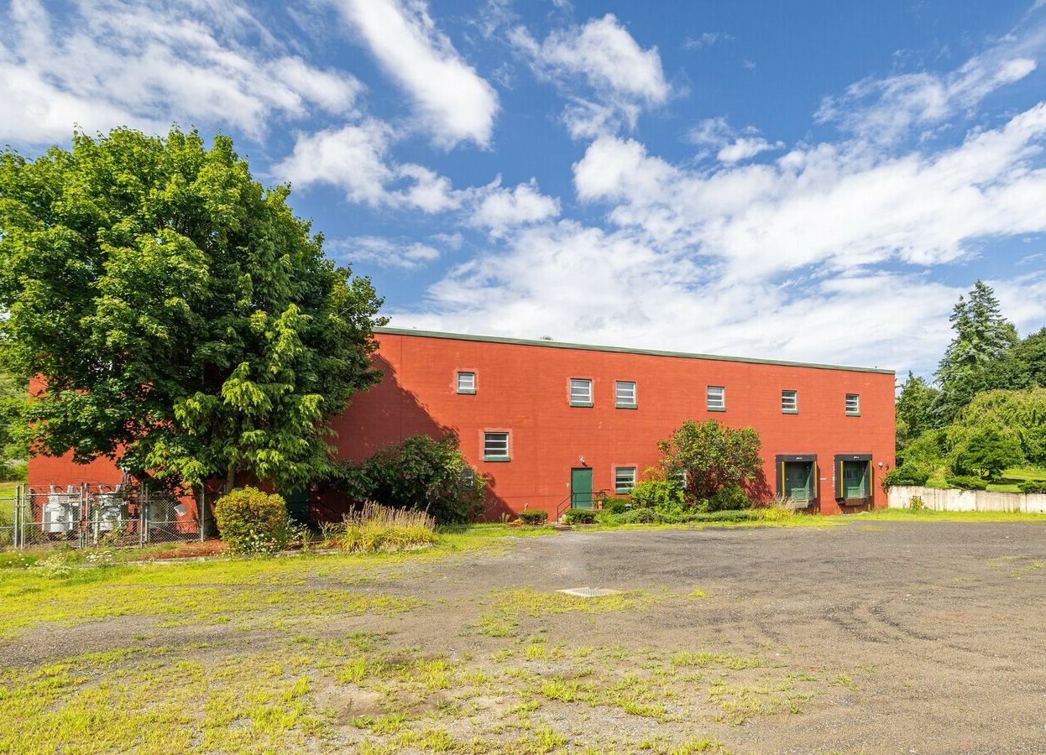
Cover photograph: 1 Main Street, Shirley, MA
MASSACHUSETTS REAL ESTATE

Property with possibility
Select commercial, mixed-use, and redevelopment opportunities across Greater Boston and Central Massachusetts.
kentventuresgroup.com

PROPERTY OPPORTUNITIES

A useful starting point for every asset
We present individual properties with the information a prospective buyer, tenant, or development partner needs to begin a serious conversation.
Commercial spaces
Existing spaces and sites for owner-users, tenants, and investors.
Land and redevelopment
Parcels and buildings with potential paths for further evaluation.
Mixed-use opportunities
Properties whose next use deserves careful review of plans and approvals.
Discuss an opportunity
kent@kentventuresgroup.com | 617-257-3544 | kentventuresgroup.com
Property details, availability, and intended uses require independent verification.

